Corporate Finance Project Details PROJECT DETAILS (Note: all amounts are in Canadian dollars.)

Bio-Fuels Generation Incorporated (BFG) is a private company that produces biomassbased diesel fuel from feedstocks, including inedible corn oil, used cooking oil, and inedible animal fats. The diesel fuel is then sold to distributors. The company is also actively involved in research into the production of other types of biomass-based fuels. Recently, the research team had a breakthrough and discovered a new production process that will produce fuel from algae at a relatively low production cost. The benefits of using algae as a feedstock for fuel production have long been known and include the fact that algae can be grown in large quantities in wastewater and can be genetically manipulated to produce many different types of fuel. But the main disadvantage to commercialization has been that algae production requires large amounts of water, nitrogen, and phosphorous, resulting in higher greenhouse gas emissions to produce algae than is saved by using it as a fuel, in addition to very high production costs. However, the BFG research team has recently discovered a process that will significantly reduce the amount of these inputs required, resulting in a very costeffective production process. BFG is owned by Eleanor Whiteman, a renowned scientist in the research of biomassbased fuels, and her husband, Michael Whiteman. Eleanor owns 300,000 common shares and Michael owns 100,000 common shares. Currently, the company has three directors on its board — Eleanor, Michael, and Sherry LePage, a long-time friend. Sherry has a PhD in Biology, specializing in algae, and teaches at the local university. With her background and experience, Sherry advises on the research conducted at the firm. She is very interested in this project of using algae to produce fuel. Eleanor is very excited about the research results because this has been her area of research for the past 20 years. BFG now needs financing to commercialize this algae production process. Michael is also excited about the company expanding into this area but has some concerns regarding how the financing should be raised and other finance issues affecting the company. You currently work as a financial analyst for HRY Consultants Inc. BFG has hired your company in the past to assist with a variety of financial issues. Yesterday, Eleanor called you, asking about work she would like completed. The following appendixes provide additional information about BFG and its financial position:
Appendix I — 20X1 and 20X2 financial statements
Appendix II — Current capital structure and financing proposals
Appendix III — Assumptions for the capital budget analysis

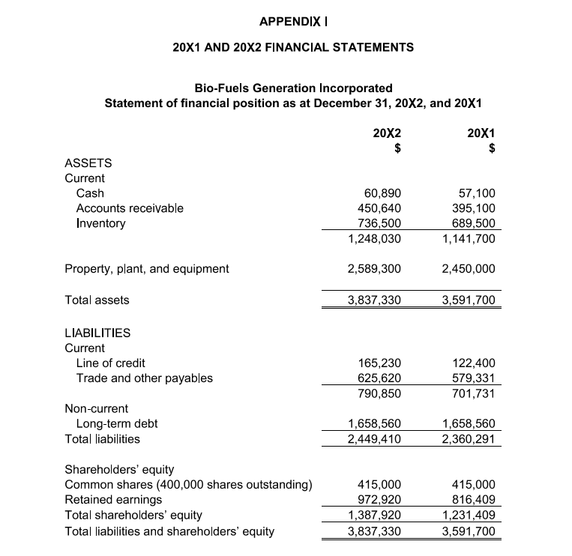
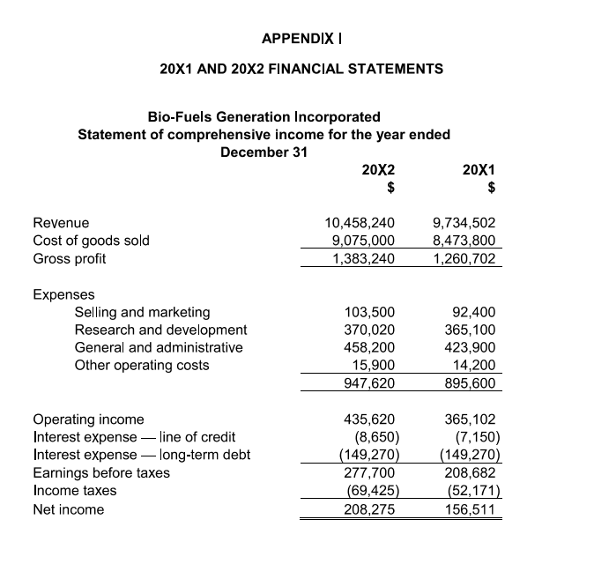
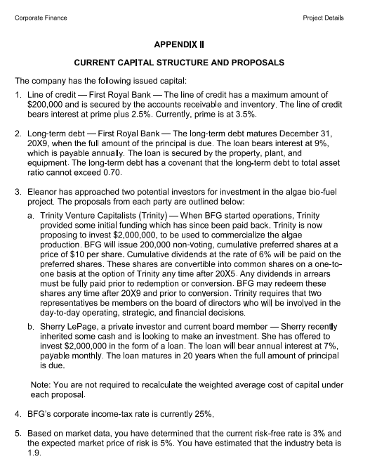

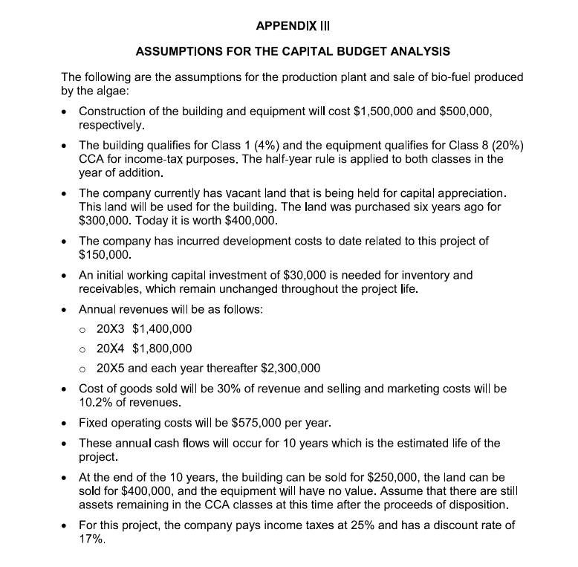

QUESTIONS

Question 1. We would like a capital budget analysis prepared for the production plant and for the sale of biomass-based fuel produced by the algae using a net present value analysis. Relevant information has been provided in Appendix III. Provide a recommendation based on your analysis?
Question 2. We used a lot of assumptions for this capital project analysis. I am concerned that the actual results might be very different from our forecasts. I have read about sensitivity analysis and scenario analysis when it comes to capital budgeting but don’t quite understand the difference. We would like an explanation of what each of these terms means. Also, could you provide four examples of factors that this project’s outcome might be sensitive to as well as one example of a sensitivity analysis and scenario analysis that could be done?

Question 3. We have been looking at the management of our working capital and need some guidance on how we should finance the investment in our current and long-term assets. We have examined our receivables and inventory and have determined that these accounts, in total, can fluctuate from a low of $950,000 to a high of $1,300,000 during the year. We would also like to maintain about $60,000 in cash as a minimum balance. For the liabilities, our payables are usually 53% of the balance in current assets (permanent or seasonal). We would like you to explain the conservative, aggressive, and moderately conservative strategies using the specific information for our company and identify which strategy BFG appears to be using and its implications.

Question 4. As part of our ongoing objective to reduce costs, we are looking at another supplier for some of our raw materials. Our current supplier, RMM Inc. provides terms of 2/10 net 45, and we have always paid within the discount period. The new supplier we are considering, TSQ Inc. is offering terms of 1/15 net 60. We think that both suppliers provide similar quality of product at the same price. The average amount of each invoice is $10,000. Based on your analysis, which supplier should we choose?

Corporate Finance Project 2 2 / 2 5. We would like a forecast of our net income projected for the next quarter, April to June 20X3. We have gathered the following information: (7 marks)
• sales — $3,900,000
• cost of goods sold — same percentage of sales as 20X2
• selling and marketing — $26,000
• research and development — $95,000
• general and administration — $115,000
• other operating expenses — $4,600

As at April 1, 20X3, the opening cash balance is $76,250 and the line of credit balance is $181,200. Starting in 20X3, the company now earns 1.5% on its cash balance. Note: Assume the cash balance and the line of credit balance do not fluctuate during the quarter. Use number of days to calculate interest expense. Round percentages to two decimals; for example, 26.67%.?

